A Successful Story from Our “Chance Project”
By Director Soledad

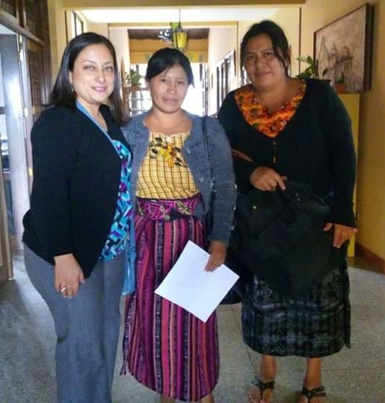
María Ana entered the Proyecto Oportunidad (Chance Project) at a difficult moment of her life. The land she inherited from her parents where she lived was stolen from her and her husband abandoned her and their children. She had no place to live, a family to feed and the only job she ever had: sell tortillas, which one can make profit around Q30/day or $4/day. She got the scholarship at Proyecto Oportunidad and started studying in 2016. (Photo: L-R, Soledad, Ana)
I explained how the scholarship process was supposed to be followed and that she would have our support to study the rest of the year. During that first meeting with the teacher, we were asked to provide her a pair of shoes because sandals are not safe in a kitchen.

She finished that first year with great grades. She learned and showed she was committed to it. The trainer suggested Ana should continue studying the next level in cooking school because she was determined to learn and succeed. We decided to give her the chance. Ana was the first lady who received a scholarship for a 2nd year, bakery school. I met her again on her first day at school during 2017, she seemed happier, more confident.
During January 2018, we were contacted by a home for girls “Lazos de Amor”. They wanted us to teach their students work skills. So we decided to give Ana the chance again. We offered her the job and an extra course so she could learn even more. Ana trained the girls in the home for two months; the directors of the home were pleased and grateful.
I am very excited as I write this story especially because it ends in a great way. María Ana is selling bread in her community but also teaching other ladies how to bake. God is not only showing His purpose for Ana´s life but for Proyecto Oportunidad…we are opening a bakery in Sumpango, Guatemala where Ana will work and teach other ladies… isn´t it amazing?

